CS 241

**12 Prove Milestone - Data Analysis**

**PART I**

*Jose Israel Carmona Morales*

To initialize the libraries and load the data:

import pandas as pd #The library that manipulates our data

import seaborn as sns #Used to plotting and graphing

import matplotlib.pyplot as plt #If we need any low level methods

bestb_players = pd.read_csv("basketball_players.csv")

print(bestb_players.head())

print(bestb_players.columns)

**OUTPUT**

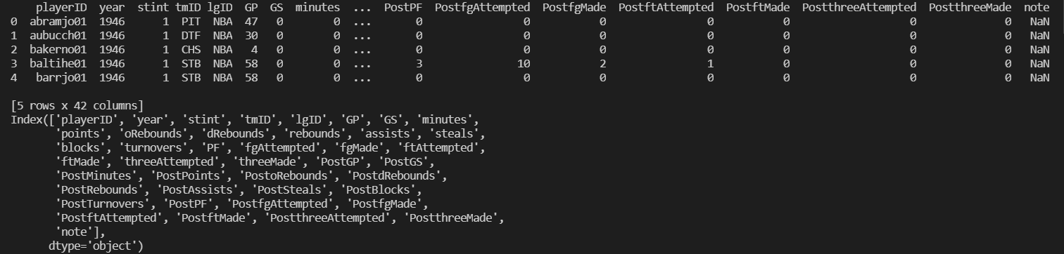

**REQUIREMENT 01.**

It finds the mean and the median of numbers of points scored.

print("Mean")

print(bestb_players.mean())

print("Median")

print(bestb_players.median())

**MEAN**

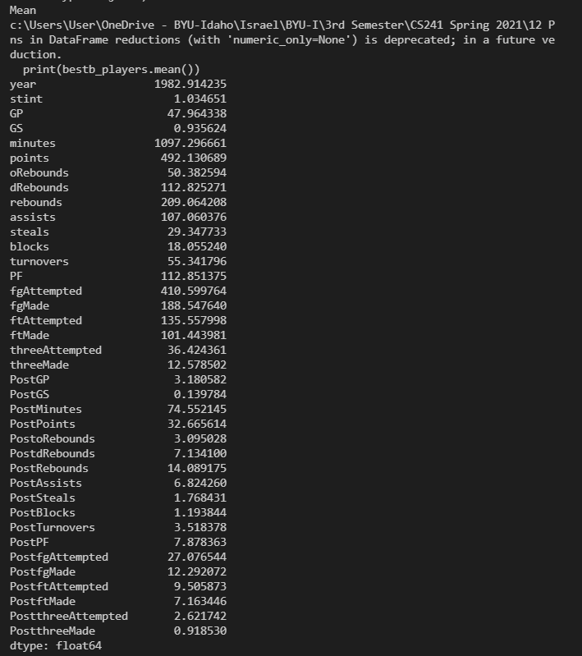

**MEDIAN**

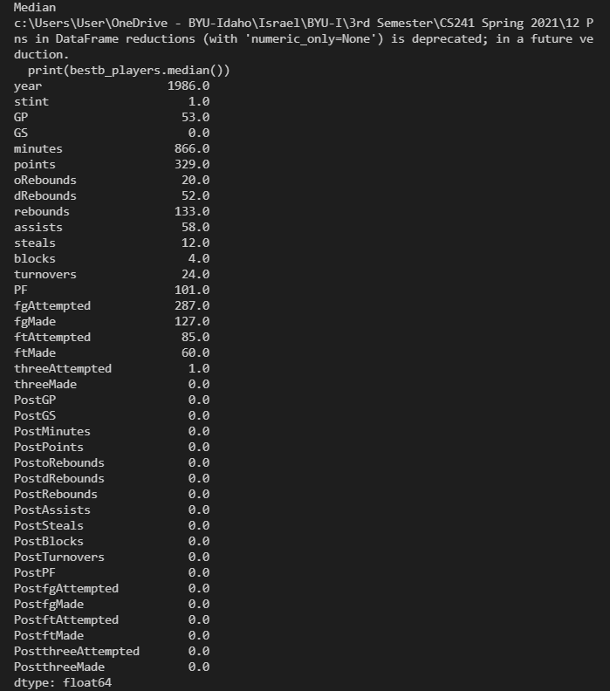

**REQUIREMENT 02.**

It finds the highest number of points per season, sorted the data by points, year and shows the highest 5.

print(bestb_players[["playerID", "year", "points"]].sort_values("points", ascending = False).head(5))

**OUTPUT**

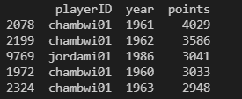

**REQUIREMENT 03.**

Produces a boxplot that shows the distribution of total points, total assists, and total rebounds.

sns.boxplot(data = bestb_players[["rebounds", "points", "assists"]])

plt.show()

**OUTPUT**

**REQUIREMENT 04.**

Produces a boxplot that shows the distribution of total points, total assists, and total rebounds.

year_nbagroup = bestb_players[["points", "year"]].groupby("year").median()

print(year_nbagroup.head())

year_nbagroup = year_nbagroup.reset_index()

print(year_nbagroup.head())

sns.scatterplot(data = year_nbagroup, x = "year", y = "points")

plt.show()

**OUTPUT**

